Manual for running the ThreeME model for results in paper “Mitigating Foreign Fossil Fuel Shocks: The Role of Renewable Energy and Industrial Electrification in the Netherlands”
Preparation
- Download Eviews, and make sure that you have a license.
- Make sure you have a github account and take the model from
  - https://github.com/ThreeME-org/ThreeME_V3-open
  - Branch: NLD-gas-price-modelling-ec-modelling-2025
  - More information on using the model – besides this document – is given under the folder ‘doc’.
Calibrate the model
- Open software program Eviews.
- Open file scr/Eviews/main.prg, via File à open à Programs.
  - Make sure that in the bottom of this file the following line is written:
call run("new", "warnings")
  - 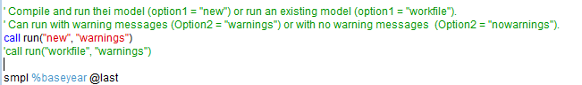
  - Note that all text in green is a comment (starting the line with quotation sign ‘).
- Run this file. (Press run in the upper left corner.)
This creates a new workfile in which the parameters are calibrated for the baseline.
Run the baseline scenario
- Open file scr/Eviews/run_extra.prg, via File à open à Programs.
  - All the information you need is under the baseline scenario:
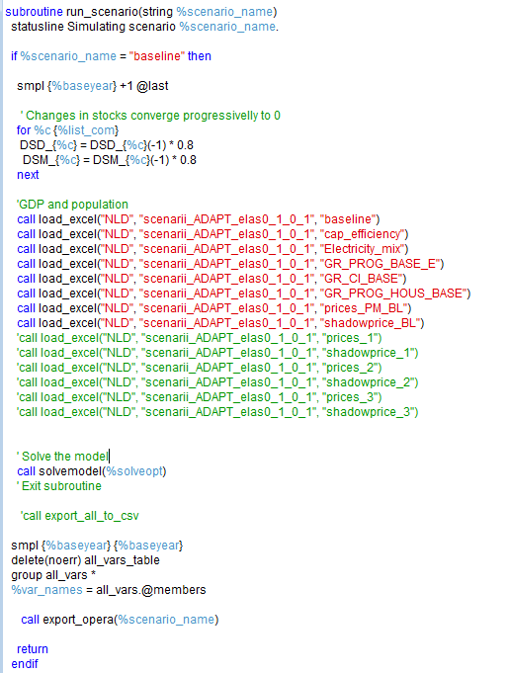
- The scenario excel files are given in folder data/NLD/. For the model results of the paper we need excel file scenario_ADAPT_elas0_1_0_1.xls.
- In this case we are running the scenario without any higher prices. Makes sure that the following lines are run:
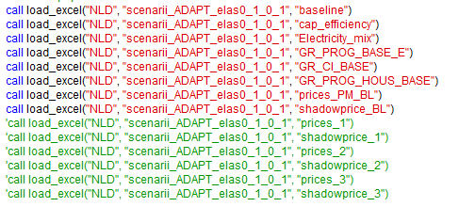
Note that the sheets ‘prices_1’, ‘shadowprice_1’ etc are not uploaded (they are only included as a comment).
- Output will – after running this scenario – automatically be saved in excel files. Note that in the folder “results” there is an excel file export_opera.xlsx. This file is used as a template by the model to create new excel files with a date-stamp. In case you like to do some post-processing on new scenarios that come out of the model, this file export_opera.xlsx can be modified.
- Make sure you save any changes to run_extra.prg before running the model.
  - Run the model by going back to the file ‘main.prg’. Make sure that – this time – the line call run("workfile", "warnings") is NOT a comment. Make the other line (call run("new", "warnings")) a comment:
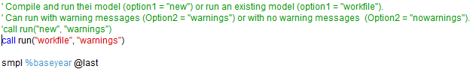

- Run main.prg by pressing run in the upper left corner.
This creates workfile that makes use of the calibrated workfile. All the variables that belong to the scenario are given with _2, all variables that belong to the calibrated baseline are indicated with _0.
All the results can also be found in the excel file under the folder “results”. Find the excel file with the latest date-stamp.
Run one of the price scenarios
- The paper presents one baseline scenario and 3 price scenarios. All four scenarios can be run under the label scenario_name = baseline. (The naming here might be confusing.) However, we will change the excel sheets that are imported for the scenario.
- For running price scenario 1, adjust the code under scr/Eviews/run_extra.prg as follows:
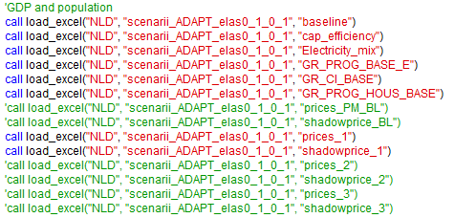
- Save the changes to this file.
- Run the scenario via pressing run in main.prg
- Note that a new excel file has been created in the folder “Results”.
For my your convenience, rename these excel files with a more intuitive addition to the name (for example reflecting that you have just run the price_1 scenario with the OPERA ADAPT energy baseline assumptions. For example: “2023-02-28_08-46-03_baseline_export_opera_ADAPT_p1.xlsx”

Creating the figures
In the folder "Results" you will also find the file Output_CMODE.xlsx.
This file will automatically create the results in figures when you copy and paste the scenario results in the correct sheet of this file:
- Baseline scenario: copy-paste the whole sheet with results in sheet Baseline_raw.
- Price scenario 1: copy-paste the whole sheet with results in sheet Trajectory1_raw.
- Price scenario 2: copy-paste the whole sheet with results in sheet Trajectory2_raw.
- Price scenario 3: copy-paste the whole sheet with results in sheet Trajectory3_raw.
So in total you will have to run the model 5 times:
- Calibration of the model.
- Baseline scenario: export results from corresponding excel file into Output_CMODE.xlsx
- Price scenario 1: Again, export results from another excel file into Output_CMODE.xlsx
- Price scenario 2: Again, export results from another excel file into Output_CMODE.xlsx
- Price scenario 3: Again, export results from another excel file into Output_CMODE.xlsx

